**Mechanical Assembly Instructions**

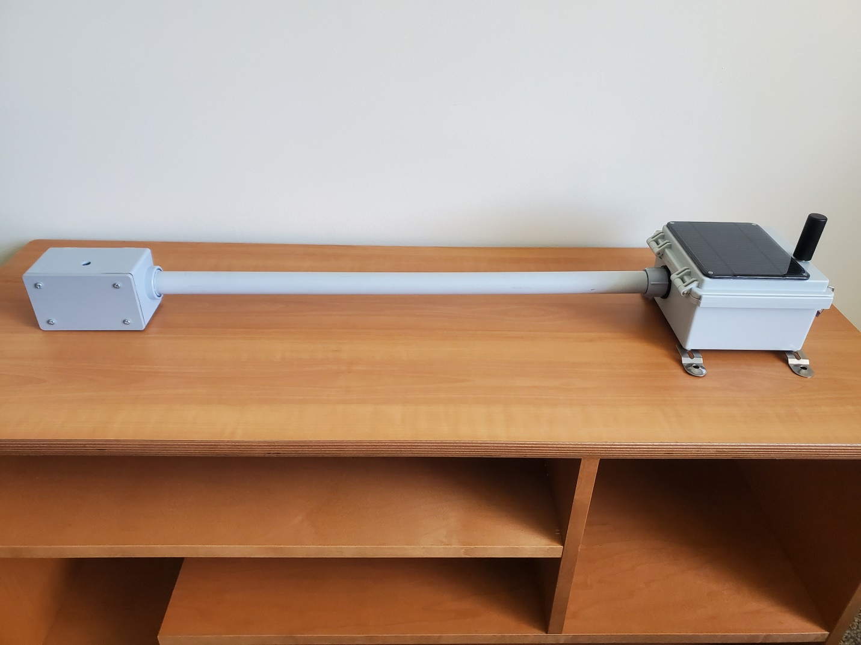

* Assembly Instructions are broken up into multiple parts:

1. Sensor Housing
2. Electronics Housing
3. Final Assembly

*Sensor Housing*

1. Using the *1-Gang FSE Box* and trim/lower the four corners circled in red by 0.15in (see Image 1).

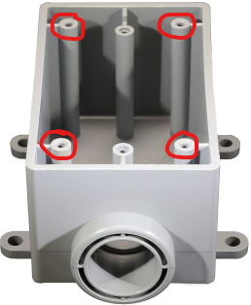

Image 1

1. Trim off the mounting feet of the *1-Gang FSE Box.*
2. Drill a 0.375in hole at the specified location (see Image 2) on both sides for the *glass lens*

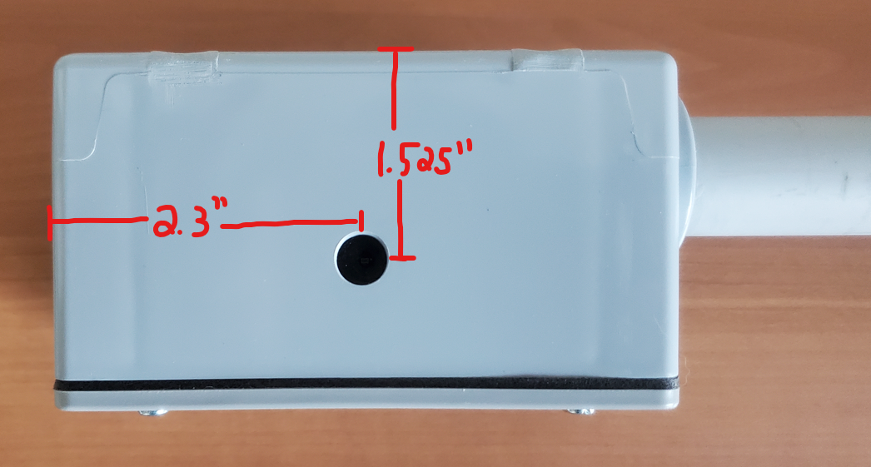

Image 2: Dimensions are based on center of the hole and outside edge of Sensor Housing

1. Place *glass lens* on the inside of the box where the drilled holes are and apply *Silicone* around the edge of the *glass lens* to hold it in place and create a waterproof seal.
2. 3D Print two *Spectrometer Mounts*, one for each sensor, using PETG or similar material
3. To install the *Spectrometers*, they need to be removed from the breakout board. The spectrometers are socketed into breakout board and can be removed by taking a small flat blade screw driver and gently prying it up from both sides (see Image 3).

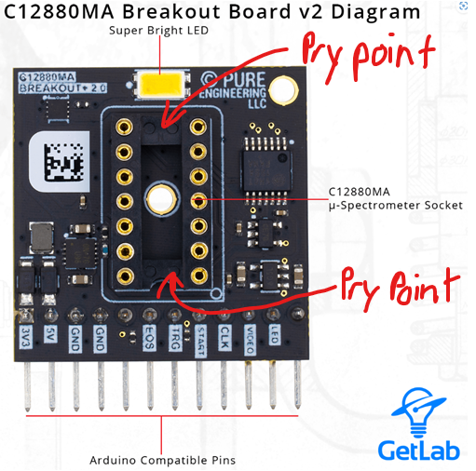

Image 3

1. The breakout boards will have Kapton tape applied to it, as it prevents shorting to the metal housing of the Spectrometer. Remove the Kapton tape and either re-use it, or cut a new piece, to apply to the underside of the Spectrometer.
2. Screw the breakout boards to the *Spectrometer Mounts* using *M2.5x6mm* screws and reinstall the spectrometers.
3. 3D Print the FOV Adaptor, one per sensor, using TPU and slip it on the sensors. The triangle and sharp corner of the FOV adaptor lines up with the sharp corner on the sensor. This is circled in red on Image 4.

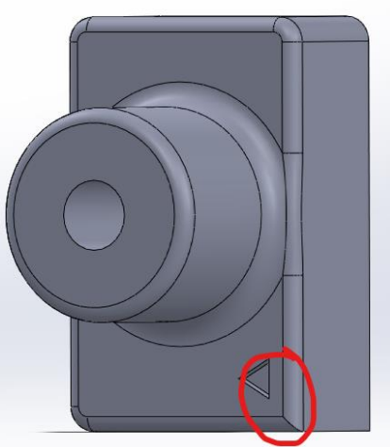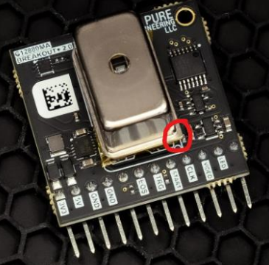

Image 4

1. Attach no shorter than *30in long jumper wires* to the pins on the sensors. There should be 6 jumper wires per sensor and they go on 5V, GND, GND, START, CLK, and VIDEO (see Image 5).

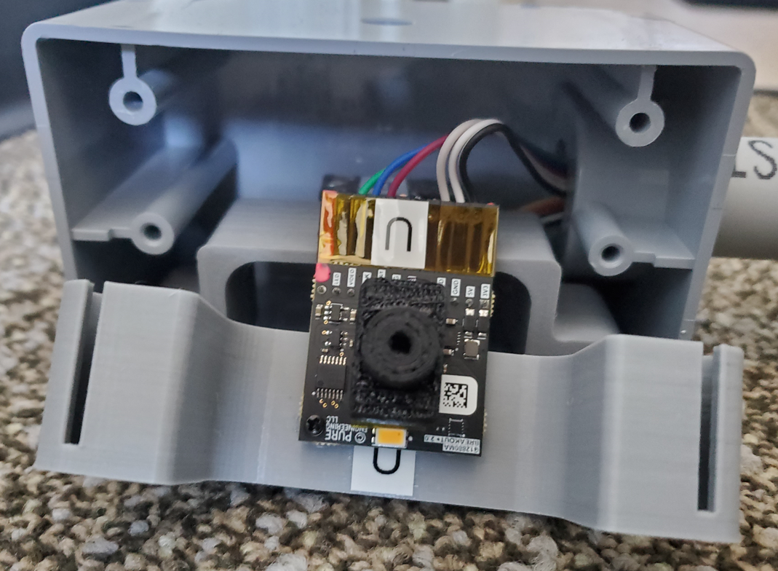

Image 5

1. Slide the *Spectrometer Mounts* onto the four trimmed corner pillars shown in Image 1 in the *1-Gang FSE Box*. The completed design should look like Image 6.

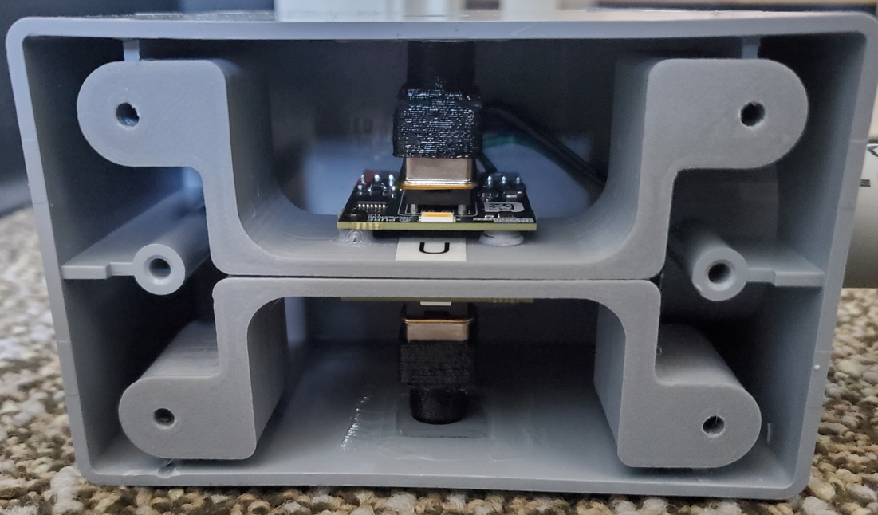

Image 6

1. Now screw on the *1-Gang Plastic Weatherproof Electrical Box Cover*. The Sensor Housing is now complete and should like Image 7.

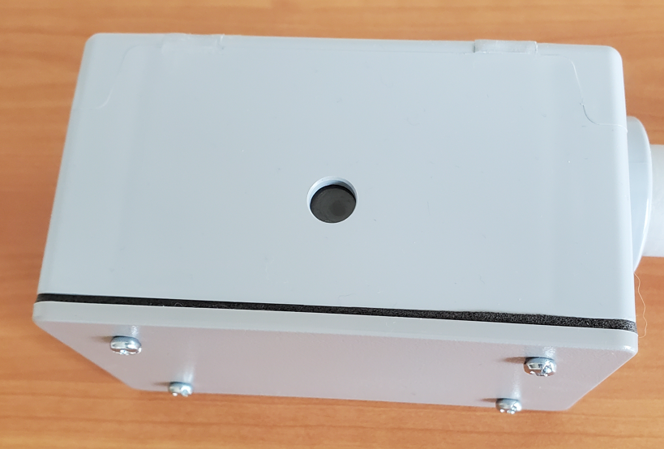

Image 7

*Electronics Housing*

1. Using the *TICONN Junction Box*, first drill a 1.0625 hole at the specified location (see Image 8).

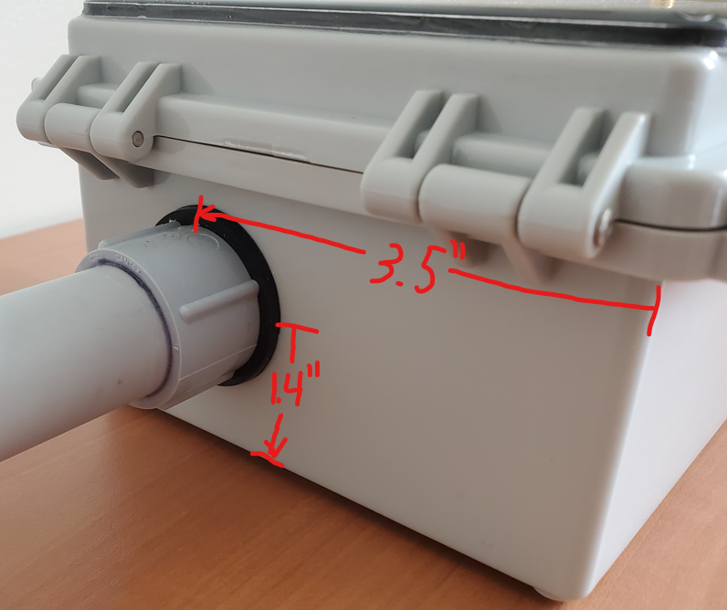

Image 8: Dimensions are based on edge of outside box to center of hole.

1. Next, drill a 4/40 lose fit clearance hole where the four screws of the solar panel are and drill a 0.316in hole for the solar panel wire at the cover of the box. Locations of Holes are shown in Image 9.

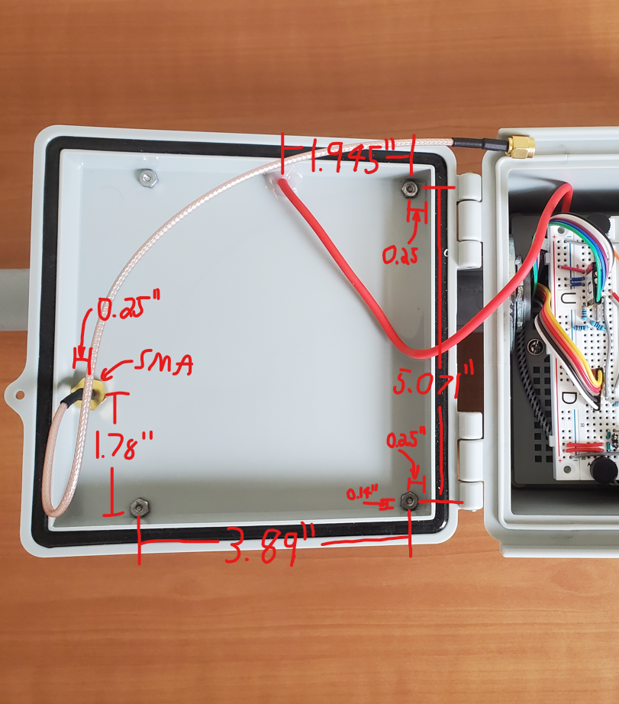

Image 9: Dimensions are based on center of the hole and inside edge of the box cover

1. Next, drill a 0.2656” hole for the *SMA Cable* on the cover of the box. Location of hole is shown in Image 9.
2. Install the *SMA Cable* and screw on the *Antenna*.
3. Next prep the *Solar Panel* by unscrewing plastic feet (shown in Image 10 in red) and apply *Silicone* on the underside of the panel around the outside edge (shown in Image 10 in blue). A *Battery Adaptor Connector* (Female 3.5x1.1mm to MicroUSB) may be installed on the end of Solar Panel cable. If so, remove it by pulling on it.

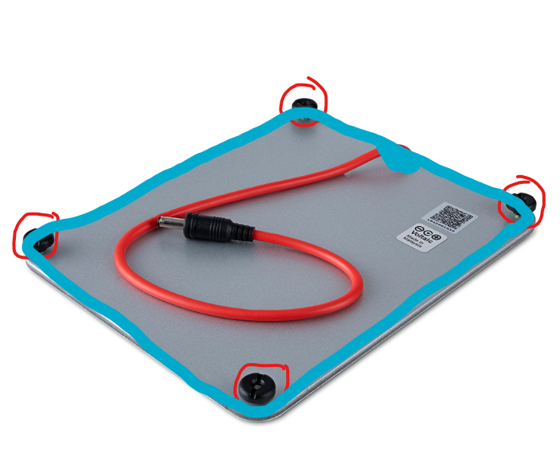

Image 10

1. To install the *Solar Panel*, slide the threaded metal posts in the holes drilled in Step 12. Screw the *4/40 nuts* on the threads from the solar panel and tighten them down. (Note that the inside of the cover where the nuts go may need to be slightly trimmed). Apply extra silicone where the cable comes through.
2. Clean any Silicone that squeezes out the sides. Reinstall the *Battery Adaptor Connector*. The cover of box should not look like Image 11

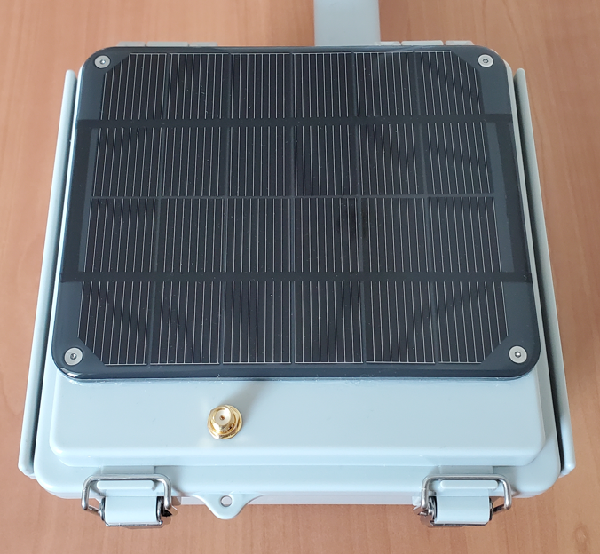

Image 11

1. Remove the *plastic plate* at the bottom of the box by unscrewing the four screws.
2. Using *four M3 screws* and *eight washers*, screw the *four M3x30mm Standoffs* at the locations shown in Image 12.

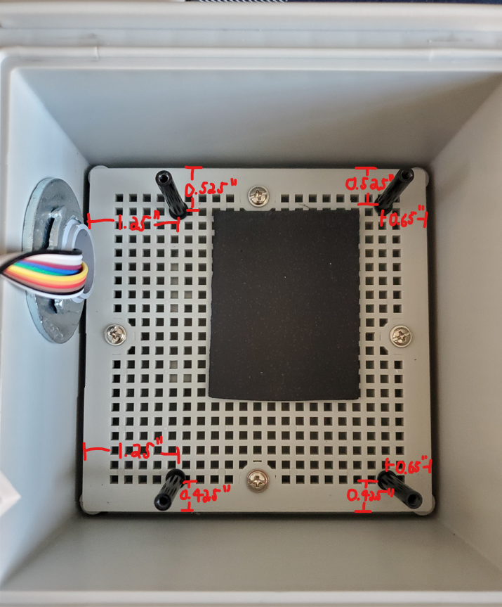

Image 12: Dimensions are based on center of the hole and edge plastic plate NOT the box

1. Before Reinstalling the *plastic plate*, 3D Print *Sat Modem Mount*, using PETG or similar material
2. Trim the plastic plate where the Sat Modem is located at Image 14/15, following the dimensions (in inches) are shown in Image 13:

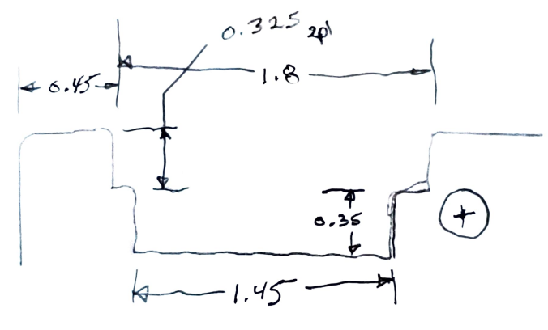

1. Using M2.5x6mm screw the *Sat Modem Mount* to the *plastic plate* and the *Sat Modem* to the mount. The mount location to the plastic plate is shown circled in red in Image 14.

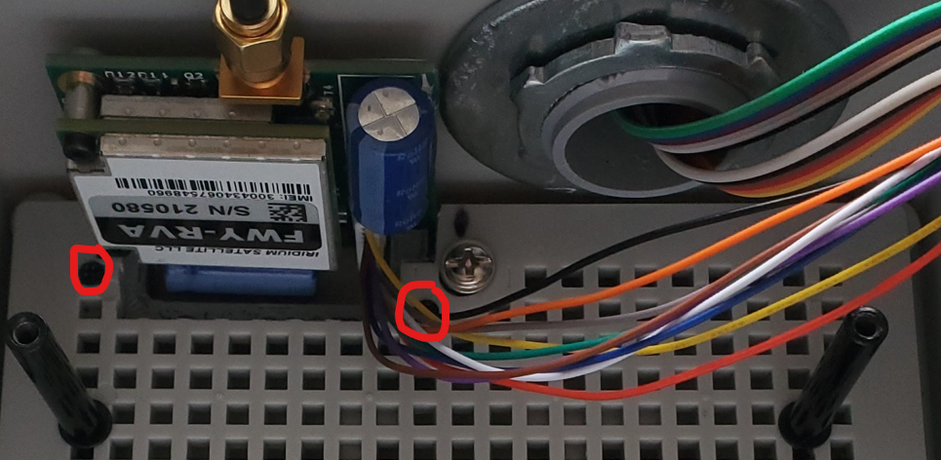

Image 14

1. Reinstall the *plastic plate.*
2. Put a *1/8in thick foam pad* as shown in Image 15.

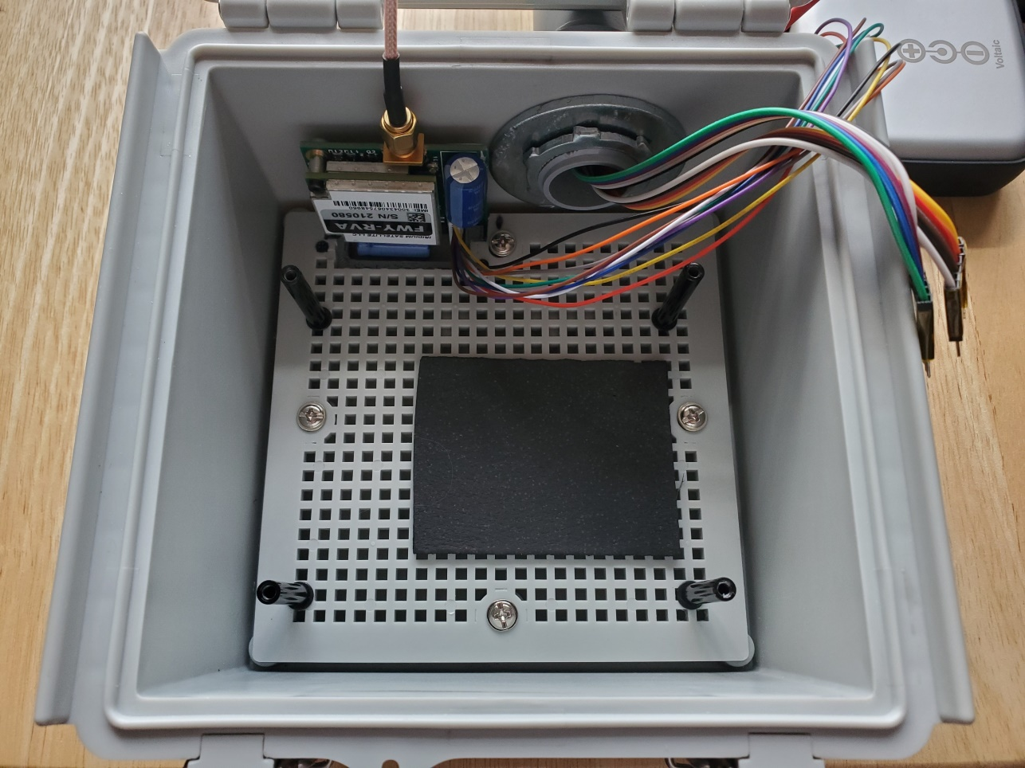

Image 15

1. Place the *Battery* on the foam pad and plug in the Solar Panel Cable to the MicroUSB on the side of the Battery. A USB to Type B cable can be placed on the bottom next the battery (shown in Image 16). ONLY PLUG THE USB CABLE INTO THE BATTERY WHEN YOU ARE READY TO USE IT AS THE BATTERY WILL ALWAYS BE ON WHEN A CABLE IS PLUGGED INTO IT.

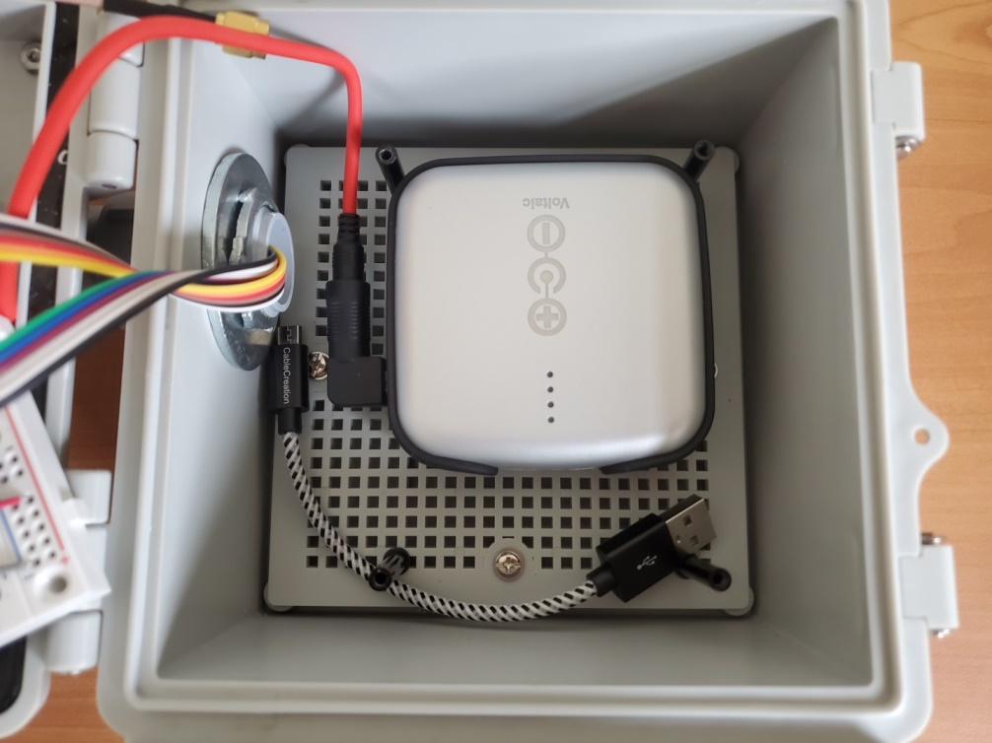

Image 16 (Sat Modem not shown in image)

1. Assemble the *breadboard* according to the Fritzing Schematic
2. Once assembled, 3D print the *RTC Mount* and install the *RTC* to the RTC Mount using M2.5x8mm screws and attach it to the breadboard using M3x16mm screws (see Image 17).

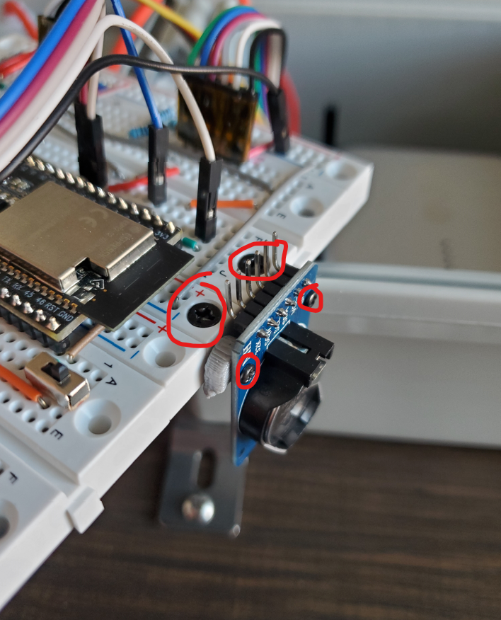

Image 17

*Final Assembly*

1. Cut the *3/4in Schedule 40 PVC Conduit* to 2ft.
2. Apply *PVC primer and glue* to one end of the PVC Conduit and to 3/4in hole on the *1-Gang FSE Box (Sensor Housing).*
3. Run the *sensor jumper wire cables* through the *PVC Conduit* and slip the PVC Conduit into the 3/4in hole on the *1-GANG FSE Box*.
4. Apply *PVC primer and glue* to the other end of the *PVC Conduit* and to *3/4in Bushing Connector Conduit Fitting*. Then slip them together.
5. Slip the 1.5in Union Washer onto the thread and put the threaded end of the *3/4in Bushing Connector Conduit Fitting* into the 1.0625 hole that was drilled in the *TICONN Junction Box (Electronics Housing)* Step 12 (see Image 18).

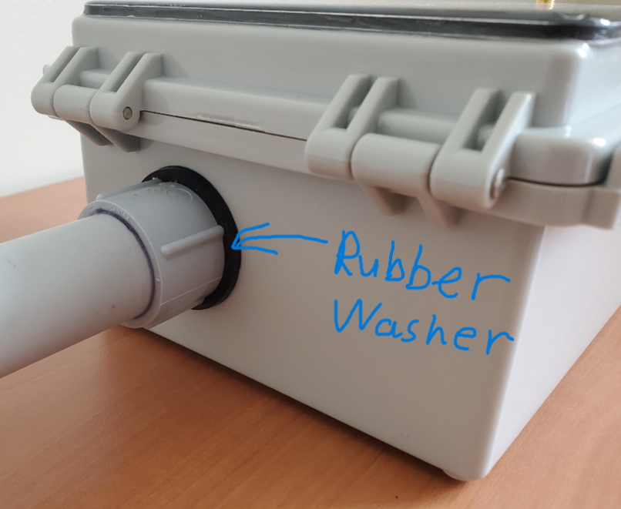

Image 18

1. Next slip on the *1in Flat Washer* on the threads from inside the box and tighten down the *Conduit Locknut (metal screw ring)*. (see image 19)

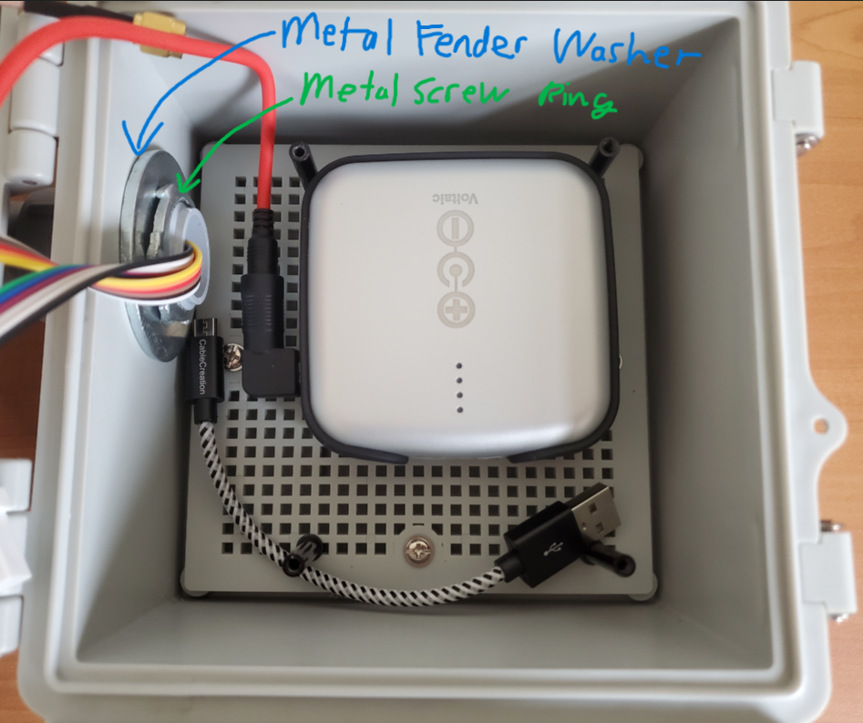

Image 19

1. Next, place another *1/8in foam pad* on top of the *battery* and use the *four thumb screws* to attach the *breadboard* to the *standoffs*. Plug in the sensors to their designated spot on the breadboard (see image 20).

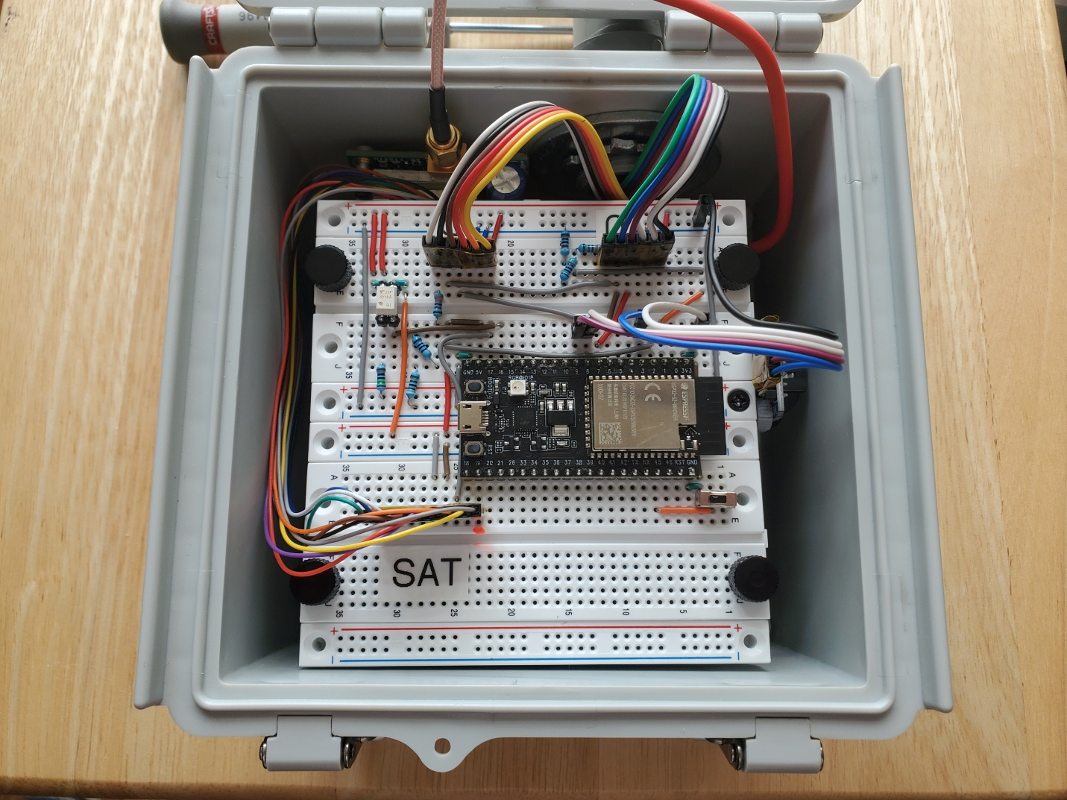

Image 20

1. Cyanosense 2.0 Prototype is now complete. Enjoy!!!